Welcome to Next Generation Occupational Medicine.
Please complete this form upon arrival and return to reception.
Name: ___________________________________________________________________________________
Date of Birth: _________________________________ Age: ______________________________________
Telephone (Home): ____________________________ (Mobile): ___________________________________
Email Address: ____________________________________________________________________________
Home Address: ____________________________________________________________________________
Next of Kin & Contact: _______________________________________________________________________
Employer: ________________________________________________________________________________
Position/Title: _________________________________ How many hours work per week? _______________
Supervisor & Contact: __________________________ How long have you been employed? ____________
Insurance Agent: ___________________________________________________________________________
Claim number: ________________________________ Case manager: _____________________________
Medicare number: __________________________________________________________________________
Treating doctor(s): __________________________________________________________________________
Clinic name/address: _______________________________________________________________________

I CONSENT TO THE BELOVE:
- Work Cover and Motor Vehicle Accident Claimants: I acknowledge that I am responsible for payment of all accounts associated with treatment of my injury if my insurer or employer suspends or discontinues payments.
- Next Generation Occupational Medicine recording and sharing information obtained from me. I understand that this may be shared with laboratories, radiological facilities, other health service providers, rehabilitation consultants, insurers, medical defence organisations, lawyers or my employer for the purpose of investigation, treatment and rehabilitation of my injury or illness, unless otherwise specified. I understand that I may revoke this consent at any time in writing.
- I understand that all appointments need to be attended. If the practice is not notified of a cancellation on 3 occasions, I understand that I will be dismissed from the doctors’ care.
- I authorise and consent for Next Generation Occupational Medicine to obtain copies of all imaging results, other results, and reports conducted in relation to the concerned injury.

Name ________________________________

Signature ________________________________ Date _______ /_____/_________

Name: _________________________ DOB: ________________ Date:

Please skip this page if you are not experiencing any pain.

- How long have you had your current pain problem? Circle one.
0-1 weeks (1) |  |  | 1-2 weeks (2) |  |  | 3-4 weeks (3) |  |  | 4-5 weeks (4) |  |  | 6-8 weeks (5) |  |  | [ ]
9-11 weeks (6) |  |  | 3-6 months (7) |  |  | 6-9 months (8) |  |  | 9-12 months (9) |  |  | Over 1 year (10)
- How would you rate the pain that you have had during the past week? Circle one
0 | 1 | 2 |  | 3 | 4 |  | 5 | 6 |  | 7 | 8 |  | 9 | 10 | [ ]
No Pain |  |  |  |  |  |  |  |  |  |  | Pain as bad as it could be
- I can do light work (or home duties) for an hour. Circle one.
0 | 1 | 2 |  | 3 | 4 |  | 5 | 6 |  | 7 | 8 |  | 9 | 10- | [ ] 10-
Not at all |  |  |  |  |  |  |  |  |  |  | Without any difficulty
- I can sleep at night. Circle one.
0 | 1 | 2 |  | 3 | 4 |  | 5 | 6 |  | 7 | 8 |  | 9 | 10- | [ ] 10-
Not at all |  |  |  |  |  |  |  |  |  |  | Without any difficulty
- How tense or anxious have you felt in the past week? Circle one.
0 | 1 | 2 |  | 3 | 4 |  | 5 | 6 |  | 7 | 8 |  | 9 | 10 | [ ]
Absolutely calm & relaxed |  |  |  |  |  |  |  |  |  | As tense & anxious as I have ever felt
- How much have you been bothered by feeling depressed in the past week? Circle one.
0 | 1 | 2 |  | 3 | 4 |  | 5 | 6 |  | 7 | 8 |  | 9 | 10 | [ ]
Not at All |  |  |  |  |  |  |  |  |  |  |  |  | Extremely
- In your view, how large is the risk that your current pain may become persistent? Circle one.
0 | 1 | 2 |  | 3 | 4 |  | 5 | 6 |  | 7 | 8 |  | 9 | 10 | [ ]
No Risk |  |  |  |  |  |  |  |  |  |  |  |  | Very Large Risk
- What do you estimate are the chances you will be working your normal duties (home or work) in 3 months?
0 | 1 | 2 |  | 3 | 4 |  | 5 | 6 |  | 7 | 8 |  | 9 | 10- | [ ] 10-
No Chance |  |  |  |  |  |  |  |  |  |  |  |  | Very Large Chance
- An increase in pain is an indication that I should stop what I’m doing until the pain decreases.
0 | 1 | 2 |  | 3 | 4 |  | 5 | 6 |  | 7 | 8 |  | 9 | 10 | [ ]
Completely Disagree |  |  |  |  |  |  |  |  |  |  |  |  | Completely Agree
- I should not do my normal work (at work or home duties) with my present pain.
0 | 1 | 2 |  | 3 | 4 |  | 5 | 6 |  | 7 | 8 |  | 9 | 10 | [ ]
Completely Disagree |  |  |  |  |  |  |  |  |  |  |  |  | Completely Agree

SUM:

Medical History

Are you right or left-handed? _______________

Please describe to the best of your ability, the injury or medical condition(s) that is currently affecting you:
Date and location of injury / illness:_______________________________________________________________________
Brief description of the event : ___________________________________________________________________________
_____________________________________________________________________________________________________
_____________________________________________________________________________________________________
_____________________________________________________________________________________________________
What problems and symptoms are you currently having? _____________________________________________________
_____________________________________________________________________________________________________
_____________________________________________________________________________________________________
_____________________________________________________________________________________________________
Description of injury or injuries (please use diagram to indicate where you feel pain – please include ALL affected areas) Please mark on the diagram the site of pain. Also mark your worst pain with an ‘x’ and mark any numbness with an ‘o’

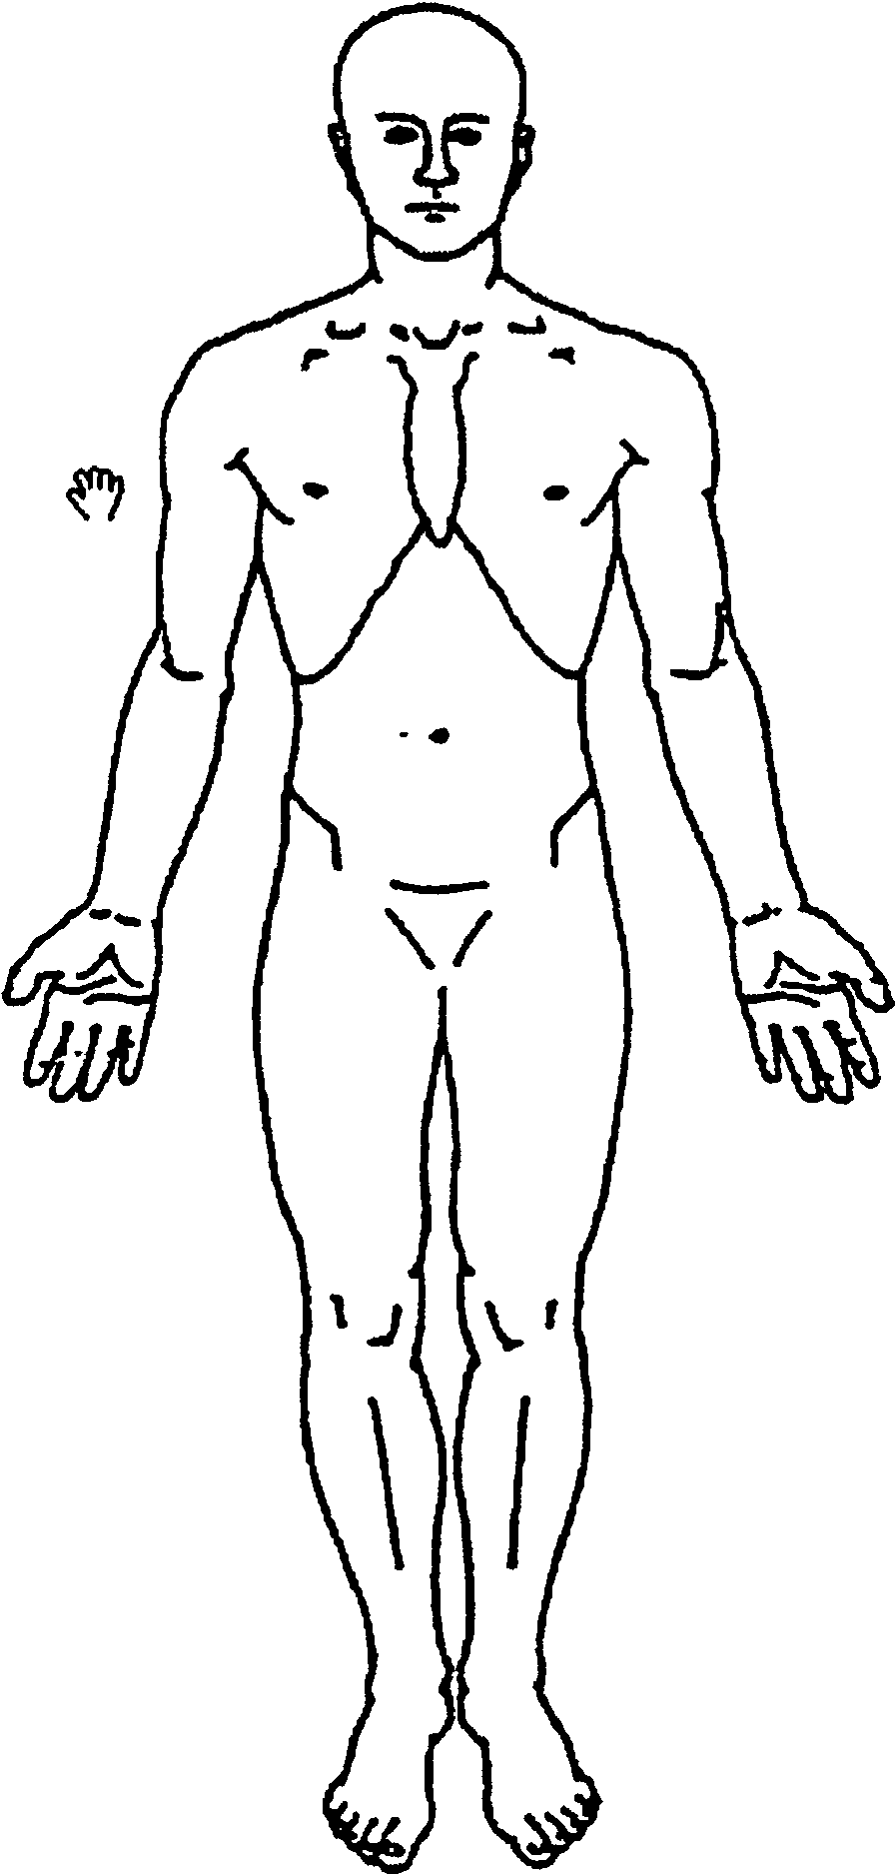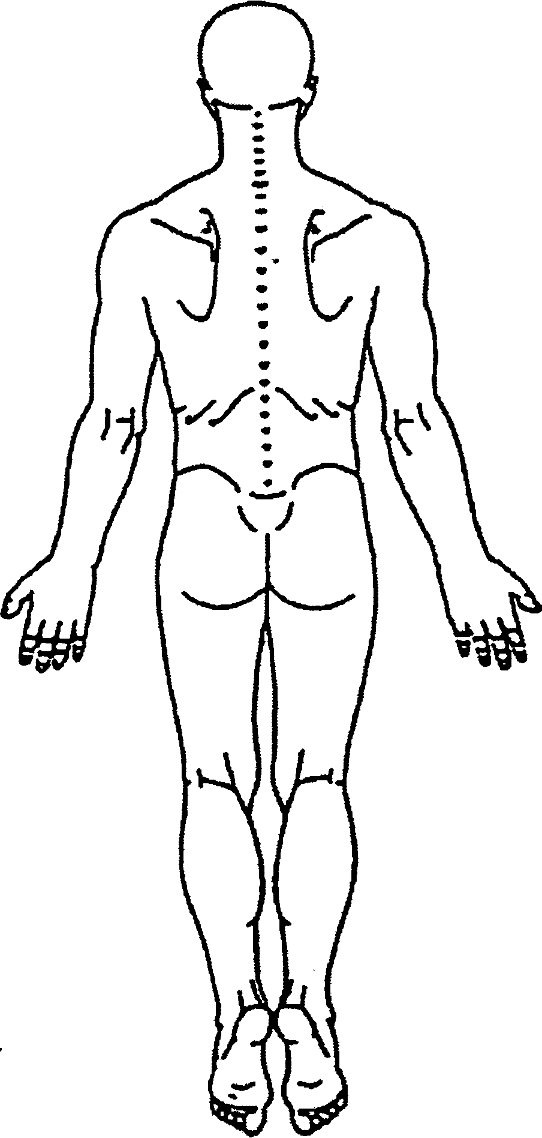

Investigations
Please tick () if you have had the following investigations for current injury and list approximate dates

X-rays _______________________________________
CT Scan ______________________________________
Bone Scan ____________________________________
MRI _________________________________________
Ultrasound ___________________________________
Nerve Studies _________________________________
Blood Tests ___________________________________
Other ________________________________________

Current treatment for injury (please tick )

Treatment type |  |  | Number of sessions |  |  |  |  | Helpfulness
Physiotherapy | Yes No |  | 1-5 | 6-10 | 11-20 | >20 |  | nil | some | very
Chiropractic | Yes No |  | 1-5 | 6-10 | 11-20 | >20 |  | nil | some | very
Hydrotherapy | Yes No |  | 1-5 | 6-10 | 11-20 | >20 |  | nil | some | very
Gym | Yes No |  | 1-5 | 6-10 | 11-20 | >20 |  | nil | some | very
Psychology | Yes No |  | 1-5 | 6-10 | 11-20 | >20 |  | nil | some | very
Acupuncture | Yes No |  | 1-5 | 6-10 | 11-20 | >20 |  | nil | some | very
TENS | Yes No |  | 1-5 | 6-10 | 11-20 | >20 |  | nil | some | very
Massage | Yes No |  | 1-5 | 6-10 | 11-20 | >20 |  | nil | some | very
Other | Yes No |  | 1-5 | 6-10 | 11-20 | >20 |  | nil | some | very

Comments: _________________________________________________________________________________________

___________________________________________________________________________________________________

Medication

Please list ALL medication you are currently taking (including those for pain) and indicate (tick box) whether or not they are helpful.

 |  |  | Benefit (tick box)
Medication | Dose | Side effect | none | mild | moderate | marked

Past Medical History

Condition | Treatment | Status

Pre-injury Job and Duties

Job Title: ___________________________________________________________________________________________

Please describe your pre-injury job duties and how do you do it: _______________________________________________

___________________________________________________________________________________________________

___________________________________________________________________________________________________

___________________________________________________________________________________________________

Are you currently off work? ________ Are you currently on work restrictions? ________ Reduced hours? _____________

If so, please explain below (include hours, work restrictions specified by doctor and description of duties):
___________________________________________________________________________________________________

___________________________________________________________________________________________________

___________________________________________________________________________________________________

Education and Personal History

Were you born overseas; if yes where? _____________________ What level of school did you complete? ____________

Have you obtained further qualifications; if so, please list them below? _________________________________________

___________________________________________________________________________________________________

___________________________________________________________________________________________________

Last 5 job positions

Where and when did you work in your last 5 years? Please include periods of unemployment or study:

Period/Year | Job Title | Employer | Reason for Leaving

Psychosocial History

Who else lives with you? ___________________________ Do you have any dependents? __________________________

What hobbies/interests do you have? ____________________________________________________________________

Have you had to change or give up any hobbies/ interests as a result of your injury(s)? If so, please explain:

___________________________________________________________________________________________________

___________________________________________________________________________________________________

Are you a smoker? __________________ (if so, please indicate how much): ________________________________

Do you drink alcohol? _________________ (if so, please indicate how much): ________________________________

Signature _______________________________________ Date __________________________________

